|  |  |
| --- | --- |
| **Name** |  |

***Full working out must be shown to get full marks.***

***Attempt all questions***

**Total Time: 60 minutes**

* **Section 1 (Calculator Free): 45 minutes 45 marks**
* **Section 2 (Calculator Assisted): 10 minutes 10 marks**

**Calculator Free**

**Question 1 (2, 2 - 4 marks)**

Find the gradient and y-intercept for each equation below.

1.  b) 

**Question 2 (4 marks)**

Identify which lines below are parallel and which are perpendicular.

  

  

 

**Question 3 (3 marks)**

Given the following function rules and the domains, find their corresponding ranges.

|  |  |  |
| --- | --- | --- |
|  | **Function Rule *f (x)*** | **Domain** |
| a) | $$4x-3$$ | $$-3≤x≤5$$ |
| b) | $$x^{2}-4$$ | $$-3≤x≤5$$ |
| c) | $$\sqrt{x+2}$$ | $$-1≤x≤10$$ |

a)

b)

c)

**Question 4 (1 marks)**

A function is defined as . Write an expanded expression for 

**Question 5 (1, 2, 2-5 Marks)**

A line passes through (3, 5) and (7, 25)

1. Find the gradient of this line
2. Find the equation of this line
3. Is (4, 10) on this line? Justify your answer.

**Question 8 (1, 1, 1, 2, 2 -7 marks)**

Given the functions f(x) = 2x − 3 h(x) = 

g(x) = x2 +2x – 8 j(x) = 4 − 

determine

(a) h(0)

(b) g(−2)

(c) f(2t – 1)

(c) x such that f(x) = j(x)

(d) the domain and range of h(x)

**Question 6 (11 marks)**

Shown below are the graphs of some mapping rules. Determine with **reasons** which of these rules are functions. Give the natural domain and range for those that are function rules.



d) e) f)

1. b) c)

1. Reason:

Domain:

Range:

1. Reason:

Domain:

Range:

1. Reason:

Domain:

Range:

1. Reason:

Domain:

Range:

1. Reason:

Domain:

Range:

1. Reason:

Domain:

Range:

**Question 7 (4 marks)**

Find the values of *a*, *b* and *c*, given that the straight line *a*x + *b*y = *c* passes through (-1,4)

and (2,5)

**Question 8 (3, 3 - 6 marks)**

Find the equation of the line through the point with coordinated (10, 3)

1. and parallel to the line with the equation $4x+5y=20$
2. and perpendicular to the line with equation $2x+3y=12$

**Mathematics Methods**

**Semester 1 2017**

**Calculator Assumed**

**Question 10 (2, 1 – 3 marks)**

The owner of a shop that sells computers calculates that his total weekly profit is given by the rule:

Total profit in dollars =,

where  is the profit per computer sold,  is the number of computers sold in the week and  is the fixed weekly cost of running the shop.

If he sells ten computers in a week his total profit is $360.

If he only sells five computers in the week he makes a loss of $190.

1. Calculate  and .
2. What is the least number of computers he can sell and still make a profit?

**Question 11 (2, 2, 3 - 7 marks)**

Shown below is a circle and a tangent line at the point (2,4)

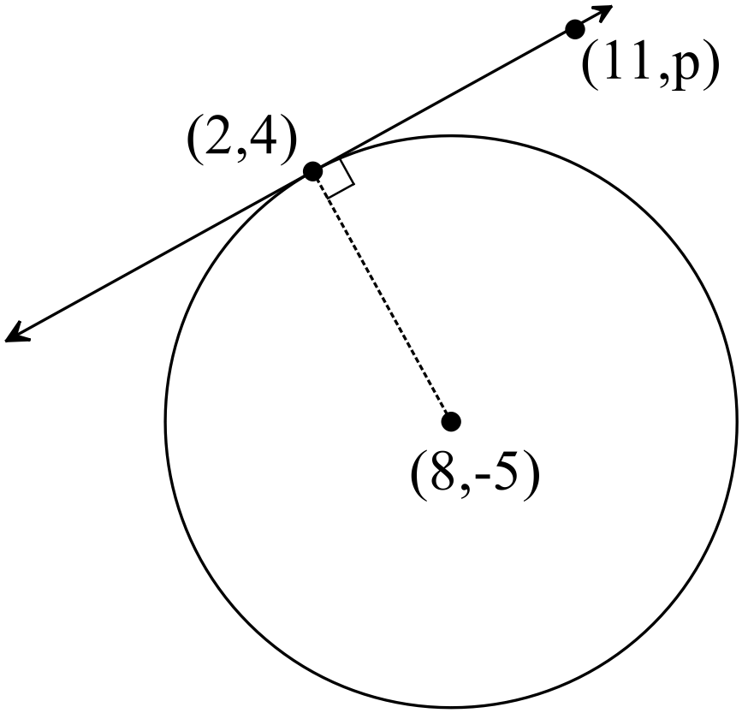

1. Determine the length of the radius of the circle, accurate to 3 significant figures.
2. Find the equation of the radius line.
3. Find the value of p, where the point (11, p) is a point on the tangent line.

End of Test